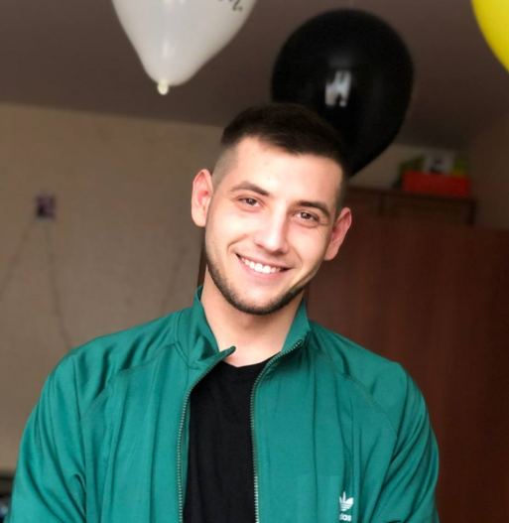**Yevheniy Martyniuk**

junior front-end

Odesa, Ukraine

Phone: +38 (050) 740 69 80

Email: [mrtevgeniy@gmail.com](mailto:mrtevgeniy@gmail.com)

Telegram: <https://t.me/martyynn>

LinkedIn: <https://www.linkedin.com/in/evgMarty/>

Github: <https://github.com/EvgMarty>

# CAREER OBJECTIVES

I am looking for a full-time job as a Trainee/Junior Front End Developer in the office or remotely.

I have experience in creating Landing Pages, and building a commercial website, and would like to work on website development. I have a great desire to work and develop in this field with other interesting people.

# BASIC TECHNICAL SKILLS

* Theoretical knowledge of:
  + *WEB-services (REST, SOAP);*
  + *HTTP/HTTPS protocols;*
  + *HTML,* BEM methodology;
  + *CSS (SCSS),* Adaptive layout*;*
  + *JavaScript;*
* Practice with:
  + *HTML;*
  + *CSS;*
  + *JavaScript;*

## EDUCATION

Vinnitsa College of the National University of Food Technologies, Junior Specialist in Electrical Equipment Servicing, September 2013 - May 2016

## MILITARY SERVICE

December 2017 - May 2018

## The completion of compulsory military service in the Armed Forces of Ukraine.

## ADDITIONAL EDUCATION

[IT STEP Academy](IT%20STEP%20Academy)

[Frontend developer](Frontend%20developer), December 2019 - September 2020

## SOFT SKILLS

* *Fast learner*
* *Creative*
* *Assertive*
* *Communicative*
* *Take criticism well*
* *Non-conflict*

**ENGLISH LEVEL**

Beginner, Elementary (А1)

## HOBBIES

I like to play video games, mostly single-player, story, on the ps platform. I am a big fan of movies and TV series, I like to spend evenings in the cinema. I also like to drive a car and go to the sea.